
Jaypee Univeristy of Information Technology, Waknaghat Solan H.P

Tutorial Sheet
Red Black Tree

Q1) State all the rules a red black tree must follow.

Q2) When it would be optimal to prefer Red-black trees over AVL trees?

a) when there are more insertions or deletions | b) when more search is needed
c) when tree must be balanced | d) when log(nodes) time complexity is needed

Q3) How can you save memory when storing color information in Red-Black tree?

a) using least significant bit of one of the pointers in the node for color information | b) using another array with colors of each node
c) storing color information in the node structure | d) using negative and positive numbering

Q4) Is the tree below a binary search tree? Is it a red black tree?
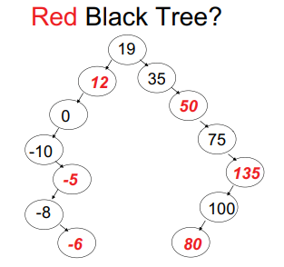

a) BST – Yes, RBT - Yes | b) BST – Yes, RBT - No
c) BST – No, RBT - Yes | d) BST – No, RBT – No

Q5) Is the tree below a binary search tree? Is it a red black tree?
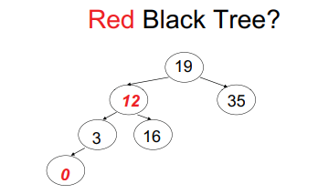
a) BST – Yes, RBT - Yes | b) BST – Yes, RBT - No
c) BST – No, RBT - Yes | d) BST – No, RBT – No

Q6) Insert a node with value 5 in the given RBT
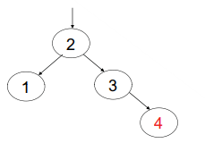

Q7) Insert a node with value 8 in given RBT
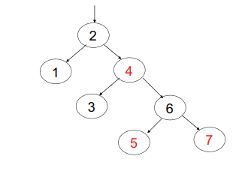
Q8) Insert a node with value 50 in the given RBT
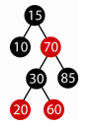

Q9) Delete a node with value 20 in the given RBT
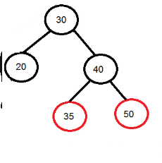

Q10) Delete a node with value 20 in the given RBT
